ENCRYPTED EDGE LABS CYBERSECURITY ANALYSIS INTERNSHIP
TASK REPORT

BY:

STUDENT EMAIL ID: samfelix15@gmaiL.com

Task 2- Introduction to networking.

COURSE INTRODUCTION:

Networking is the backbone of modern communication, enabling devices to share resources, exchange data, and communicate seamlessly. At its core, a network comprises hardware and software components that work in tandem to facilitate data transmission. The OSI model, a 7-layered framework, provides a structured approach to understanding networking concepts, ranging from physical connections to application-layer protocols.
Effective networking enables devices to communicate, share resources, and exchange data, forming the foundation of modern computing. As technology continues to evolve, understanding networking fundamentals becomes increasingly essential for harnessing the power of connected devices.

COURSE OBJECTIVES
- Build a strong foundation in networking concepts such as IP addressing, subnetting, and the OSI model.
- Develop familiarity with key network protocols and their role in secure communication.
- Capture and analyze network traffic using Wireshark, focusing on identifying and examining various protocols.
- Gain skills in understanding networking fundamentals and using Wireshark for traffic analysis to troubleshoot network issues, capture key network traffic, and identify potential vulnerabilities. Additionally, develop hands-on experience in configuring and analyzing network components to enhance overall network security and performance.

COURSE REQUIREMENT:
Tools used for my reports include
- Wireshark
- Nmap (zenmap GUI) and Ncat
- Cisco Packet tracer

SECTION A

OSI Model Summary
The OSI (Open Systems Interconnection) model is a 7-layered framework that standardizes communication between devices on a network. Each layer has a specific function, ensuring reliable data transfer between systems. The 7(models) consist of the Physical, Datalink, Network, Transport, Session, Presentation and Application.
Layer 1: Physical
In lame man terms, you can describe the physical 0s and 1s exchange between hosts or data between two different host. The physical layer,
Defines physical means of data transmission (cables, fibre optic cables, wireless transmission etc.
Establishes network topology and transmission methods
Also play the role for bit-level transmission
Layer 2: Data Link
The datalink allows individual systems to be addresses in such a way that, Ethernet frames get to the right spot. Other functions include
The error-free transfer of data frames between device
Provision of framing, error detection/correction, and flow control
The link layer is also divided into two sublayers: Logical Link Control (LLC) and Media Access Control (MAC)
Layer 3: Network
In the network layer, is responsible for sending the actual packet (logical address) but keeps source and destination address, just in case there’s supposed to be a reply or data been sent back. In general its responsibility is to,
Route data between devices on different networks
Provides logical addressing (IP addresses) and routing Ensures data is delivered to the correct destination.
Layer 4: Transport
Transport layer assembles and disassembles different pieces of data that comes in.It also, Ensure reliable data transfer between devices
Provides segmentation, connection establishment/termination, and flow control
Transport layer is also divided into two sublayers: Connection-Oriented (TCP) and Connectionless (UDP)

Layer 5: Session
Session describes the part of your host that makes connection to another host. It
Establishes, maintains, and terminates connections between applications
Manages dialogue between applications and controls data exchange
Layer 6: Presentation (P)
Presentation makes sure the data gets to the right application and also in the right format that the application can view. That is, it is responsible for
- Converting data into a format understandable by the receiving device
- Ensuring data is presented in a consistent and standardized manner
- Handling encryption, compression, and formatting
Layer 7: Application (A)
The application layer provides services to end-user applications (email, file transfer, etc.)
Supports functions like authentication, authorization, and data formatting
The OSI model enables standardized communication between devices, ensuring reliable data transfer and efficient network operation. ‎

UNDERSTANDING IP ADDRESSING AND SUBNETTING

IP addressing is the process of assigning a unique address to each device on a network. In other hand, you can explain IP addressing as a way devices talk to each other over a network .each device retain a unique IP for the purpose of services regarding to network. Also, it allows devices to access resources on the network.
Subnetting on the other hand, is the process of dividing a large network into smaller, more manageable sub-networks. This is done by dividing the IP address into two parts such as the network ID and the host ID. Subnetting allows for more efficient use of IP addresses and improved network organization, improved security and efficient allocation if resources.
Below is a breakdown of the description of the two concept,
IP Addressing Concepts:
An Ip address is a 32-bit address assigned to a device on a network.
An Ip Address Format comes in a dotted decimal notation (XXX.XXX.XXX.XXX).
An Ip address Network ID (NetID)*: Identifies the network (first 3 octets).
An Ip address Host ID (HostID) : Identifies a device on the network (last octet).
An IP address is categorised into 5 classes of address(A-E) which consists of

Class A
Address range: 0.0.0.0 to 127.255.255.255
Default subnet mask: 255.0.0.0
Number of networks: 128
Number of hosts: 16,777,216
Class B
Address range: 128.0.0.0 to 191.255.255.255
Default subnet mask: 255.255.0.0 Number of networks: 16,384
Number of hosts: 65,536
.
Class C
Address range: 192.0.0.0 to 223.255.255.255
Default subnet mask: 255.255.255.0
Number of networks: 2,097,152
Number of hosts: 256
Class D
Address range: 224.0.0.0 to 239.255.255.255
Used for multicasting
Class E
Address range: 240.0.0.0 to 254.255.255.255
Reserved for future use
Subnetting Concepts:
A Subnet ID (SubnetID) Divides the network into sub-networks.
A Subnet mask defines the scope of the subnet (255.255.255.255).
Subnetting benefits Improved network organization, security, and scalability.
Key Concepts:
1.Classful IP Addressing: IP addresses divided into 5 classes (A-E).
2. Classless Inter-Domain Routing (CIDR) : Replaced classfull IP addressing.
3. Variable length Subnet Masks (VLSM) : Allows for flexible subnetting.
4. Subnetting technique: Fixed-length subnetting, variable-length subnetting.
Why are IP Addressing and Subnetting Important?
1. Unique iIdentification: IP addressing ensures each device has a unique address.
2. Efficient communication: IP addressing enables devices to communicate with each other.
3. Network organization: Subnetting improves network organization and scalability.
4. Security: subnetting helps improve network security by isolating devices.
Real-World Applications:
Networking: IP addressing and subnetting are crucial for network design and implementation.
Cybersecurity: Understanding IP addressing and subnetting helps cybersecurity professionals secure networks.
Cloud Computing: IP addressing and subnetting are essential for cloud computing and virtual networking.
In summary, IP addressing and subnetting are fundamental concepts in networking that enable devices to communicate with each other and improve network organization and security. ‎

Below is a network logical topology displaying fundermental comprehension of IP addressing and subnetting.

Cisco Packet Tracer results

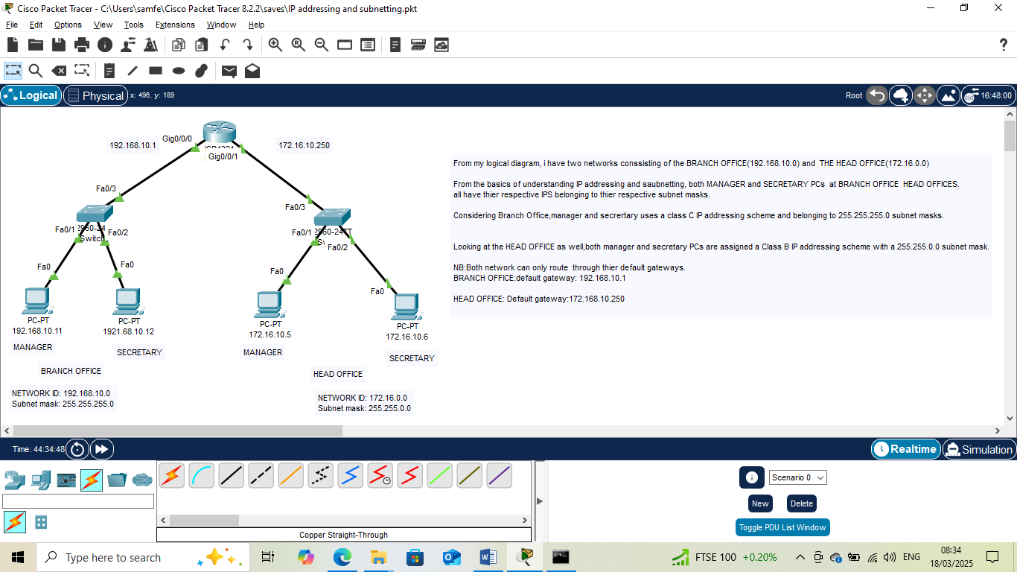

Below my Logical topology is a screenshot of my Protocol Data Units of data packets traffic across IPs residing in same and different subnets
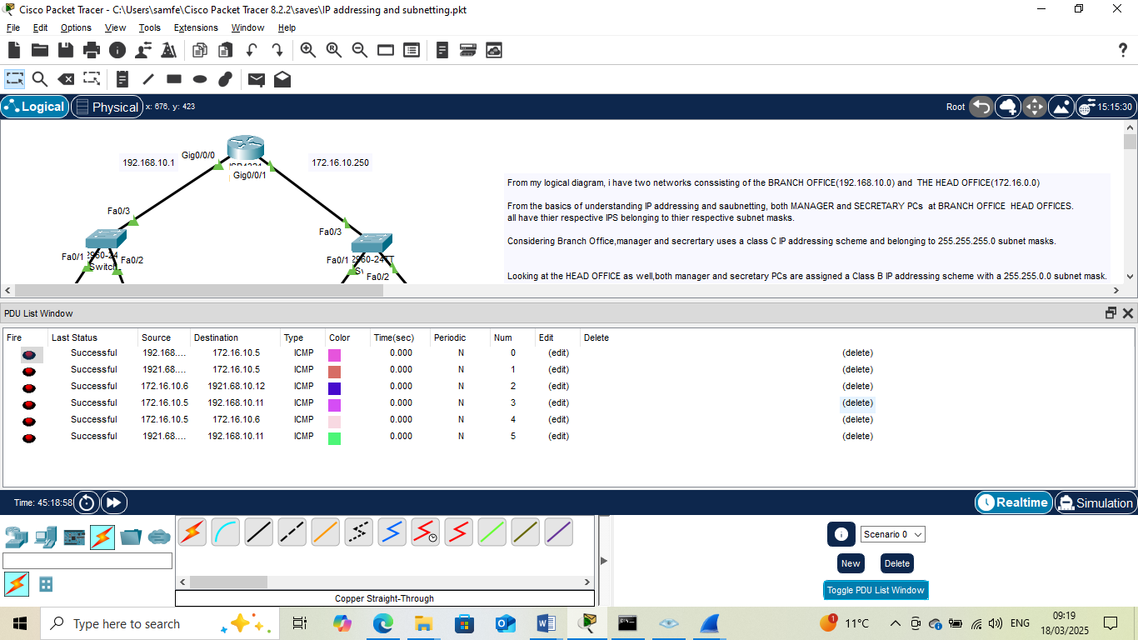

SECTION B

- HTTP/HTTPS
Purpose: Hypertext Transfer Protocol (HTTP) is used for transferring data, including web pages, over the internet. HTTPS (Hypertext Transfer Protocol Secure) is an extension of HTTP that adds encryption for secure communication.
Functionality:
HTTP: Requests and receives web pages from servers
HTTPS: Encrypts data using TLS (Transport Layer Security) or SSL (Secure Sockets Layer).SSL and TLS ensures web traffic encryptions.
Application in Cybersecurity:
Secure communication: HTTPS ensures data confidentiality and integrity
Authentication: HTTPS verifies the identity of websites and servers
Data protection: HTTPS protects against eavesdropping, tampering, and man-in-the-middle attacks
NB: HTTP listens on port 80 and HTTPS on port 443
2. FTP (File Transfer protocol)
Purpose :File Transfer Protocol (FTP) is used for transferring files over the internet.
Functionality
Uploads and downloads files between clients and servers
Supports various file transfer modes (e.g., binary, ASCII)
Application in Cybersecurity:
Secure file transfer: FTPS (FTP over SSL/TLS) or SFTP (Secure File Transfer Protocol) ensure secure file transfers
Access control: FTP servers can be configured to restrict access to authorized users
Data protection: FTP can be used to transfer encrypted files
File transfer protocol listens on port 21 and 20 ( 21 for passive and 20 for active)
3. SNMP
Purpose ; Simple Network Management Protocol (SNMP) is used for monitoring and managing network devices.
Functionality:
Requires a Snmp client,( management information base) and
- Collects and manages data from network devices (e.g., routers, switches)
- Supports various management operations (e.g., get, set, trap)
SNMP listens on port 161 and 162. Or 10161 and 10162 for encryption.
Application in Cybersecurity:
- Network monitoring: SNMP helps detect security-related issues and anomalies
- Configuration management: SNMP enables secure configuration of network devices
- Incident response: SNMP facilitates rapid response to security incidents
4. DNS
Purpose: Domain Name System (DNS) is used for translating domain names to IP addresses.
Functionality:
Resolves domain names to IP addresses
Supports various DNS record types (e.g., A- ipv4 Address, AAAA-ipv6 Address, MX-mail exchange, NS-Name Server).
Application in Cybersecurity:
Domain name security: DNSSEC (DNS Security Extensions) ensures the authenticity and integrity of DNS data
Malware protection: DNS-based filtering can block access to malicious websites
Incident response: DNS analysis can help identify and respond to security incidents
In summary, these protocols play critical roles in various aspects of cybersecurity, including:
Secure communication (HTTP/HTTPS, FTPS/SFTP)
Network management and monitoring (SNMP)
Domain name security and malware protection (DNS)
Incident response and configuration management (SNMP, DNS) ‎
Nb; Domaine Name Systems listens on Tcp port 53

After successfully running netcat, I made some interactions running netcat with the --help command to display useful arguments that can be issued with netcat. However,I have been able to simulate an HTTP,DNS,FTP request and have been included in my attached screenshots and these are my discoveries.

For simulating an HTTP request using netcat,we have the command
ncat -c –v example.com 80
Here:
-c : Send CRLF (Carriage Return Line Feed) at the end of each line (HTTP protocol requires this)
-v : Verbose mode (shows more detailed output)
example.com: The domainX name you want to test
80: The port number for HTTP (you can also use 443 for HTTPS)
When you run this command, ncat will:
1. Resolve the domain name example.com to an IP address using DNS.
2. Establish a TCP connection to the resolved IP address on port 80.
3. Send an HTTP request (in this case, an empty request).
4. Display the response from the server, if any.
By analyzing the output, you can verify if:
The DNS resolution is successful.
The HTTP request is sent correctly
The server responds as expected.
Note: This method sends a minimal HTTP request, which might not trigger all server-side processes. For more advanced testing, consider using tools like curl or wget
To check for DNS resolution using Netcat, you can use the following command:
Check DNS Resolution:
nc -u -v example.com 53
Here:
-u : Use UDP instead of TCP (DNS typically uses UDP)
-v : Verbose mode (shows more detailed output)
example.com` : The domain name you want to test
53 : The port number for DNS
When you run this command, Netcat will:
1. Send a DNS query for the specified domain name to the DNS server.
2. Display the response from the DNS server, if any.
If the DNS resolution is successful, you should see a response indicating that the domain name was found, along with the corresponding IP address.
Note:
This method only checks for DNS resolution and does not verify whether the resolved IP address is actually reachable.
The -u option is used to specify UDP, as DNS typically uses UDP for queries. The53 port number is the standard port for DNS.
To check for file transfer over FTP using Netcat, you can use the following commands:
Step 1: Connect to the FTP server:
nc ftp.example.com 21
Here:
ftp.example.com : The FTP server you want to connect to
21: The port number for FTP
Step 2: Log in to the FTP server:
USER username
PASS password
Replace `username` and `password` with your actual FTP credentials.
Step 3: Transfer a file:
ETR filename
Replace `filename` with the name of the file you want to transfer.
Step 4: Verify the file transfer:
Check the output of Netcat to verify that the file was transferred successfully.
Note:
TheRETR command is used to retrieve a file from the FTP server.
You can also use the STOR command to store a file on the FTP server.
Make sure to replace `ftp.example.com`, `username`, `password`, and `filename` with your actual FTP server details and file name.
Also, you can use netcat -v-option to enable verbose mode, which will show more detailed output:
nc -v ftp.example.com 21

Below contains screenshot of simulated HTTP,DNS AND FTP requests using Netcat

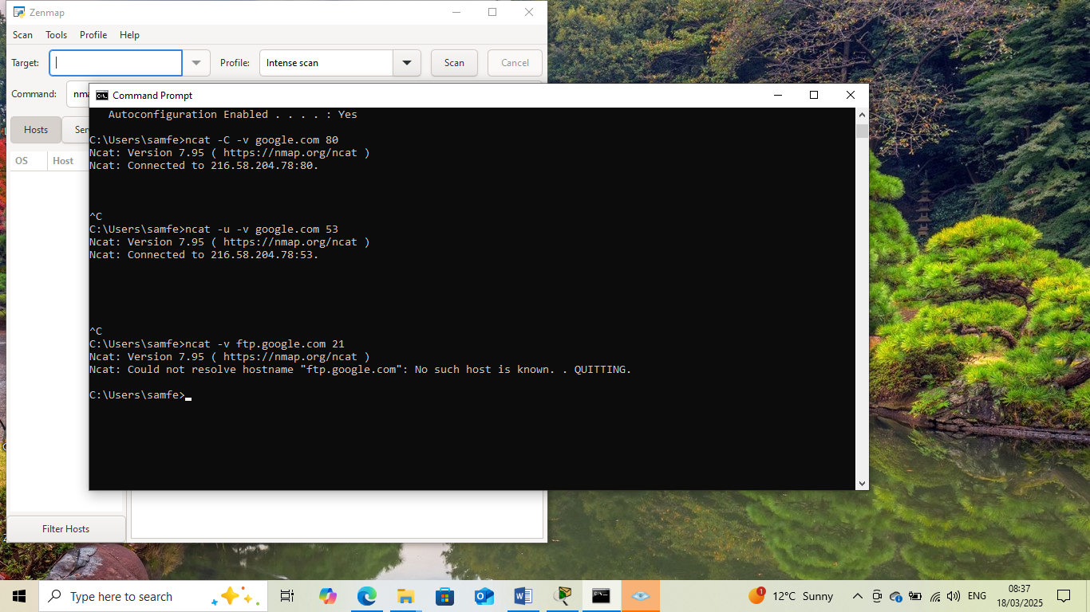

SECTION C
Analyzing data packets using wireshark enhances your skills and ability to scrutinize data packets and also provide insights into:
Network communication : Packet analysis reveals how devices interact, including protocols, ports, and data exchanged.
Performance issues: Packet capture helps identify bottlenecks, latency, and packet loss, enabling troubleshooting.
Security threats Analysis detecting potential security risks, such as malware, unauthorized access, or suspicious traffic patterns.
Protocol usage: Wireshark shows which protocols are used, helping optimize network configuration and resource allocation.
Data transmission: Packet analysis reveals data transmission details, including packet size, transmission time, and errors
Device behavior: Insights into device behavior, such as network discovery, DNS queries, and connection establishment.
These insights enable network administrators, security professionals, and developers to:
- Troubleshoot network issues
- Optimize network performance
- Enhance security measures
- Improve application development
- Conduct network forensics.

NB kindly find attached screenshot below displaying my completed Intro to Networking.

Data Flow:
1. Understanding traffic patterns: Data flow helps you visualize how data is transmitted between devices, making it easier to identify unusual traffic patterns, bottlenecks, or security threats.
2. Identifying communication endpoints: By analyzing data flow, you can determine which devices are communicating with each other, including IP addresses, ports, and protocols used.
3. Troubleshooting network issues : Data flow analysis helps you pinpoint problems, such as packet loss, latency, or congestion, by examining the flow of data between devices.
Protocol Type:
1.Identifying protocol usage: Protocol type helps you determine which protocols are being used on the network, such as TCP, UDP, HTTP, FTP, or others.
2. Analyzing protocol-specific issues: By examining protocol-specific traffic, you can diagnose issues related to protocol configuration, implementation, or compatibility.
3. Security analysis: Protocol type analysis helps you identify potential security threats, such as malicious protocol usage or unauthorized access attempts.
Significance in Network Analysis:
1. Network optimization: Understanding data flow and protocol type helps you optimize network performance, improve resource allocation, and enhance overall network efficiency.
2. Security monitoring: Analyzing data flow and protocol type enables you to detect and respond to security threats, such as intrusion attempts, malware, or unauthorized access.
3. Troubleshooting: Data flow and protocol type analysis facilitates troubleshooting by helping you identify the root cause of network issues, reducing downtime, and improving network reliability.
In Wireshark, you can analyze data flow and protocol type using various tools and features, such as:
-Flow Graph : Visualizes data flow between devices.
-Protocol Hierarchy : Displays protocol usage and statistics.
- Packet Details : Provides detailed information about individual packets, including protocol type and data flow.
- Filters : Allows you to filter traffic based on protocol type, data flow, and other criteria.
Below is screenshots of capture TCP and UDP packets using Wireshark. This screenshot displays frame check sequence number,Ack,source and destination IPs,underlying protocols and their respective port numbers.

Fig1.1 UDP captured packet

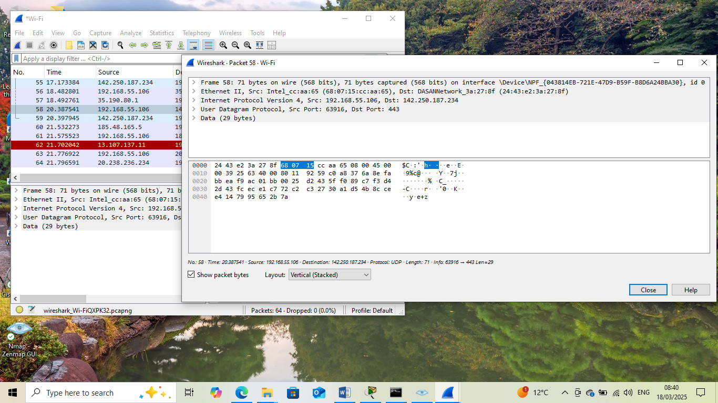

Fig 1.2 TCP Captured Packet

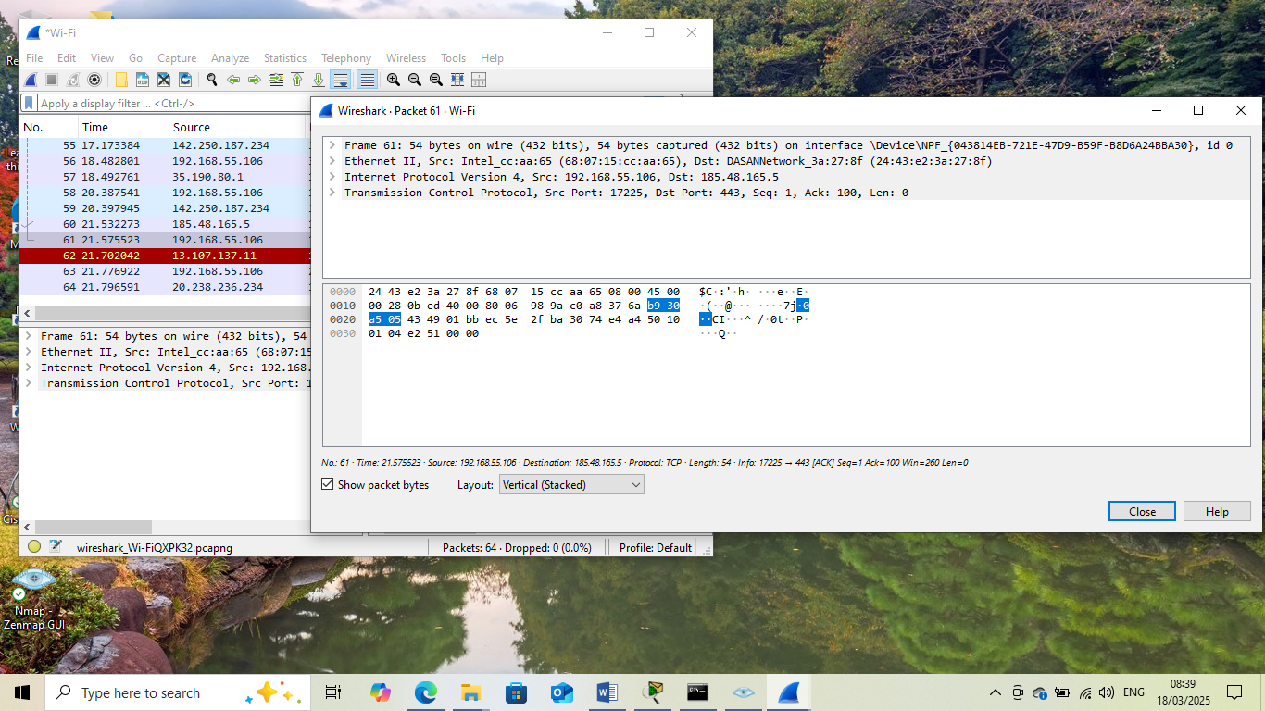

FIG 1.3 Contains screenshot of proof of Lab Completion screenshots of ‘Intro To Networking.

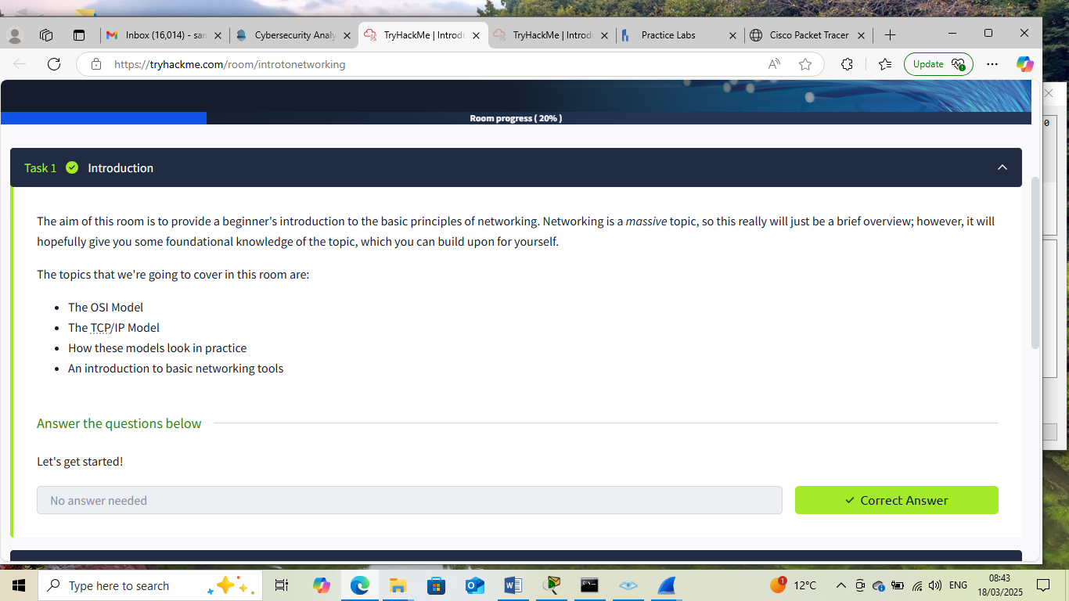

REPORT SUMMARY

This report provides a comprehensive overview of the fundamental concepts of networking. We explored the basics of networking, including the definition, importance, and types of networks. The report delved into the OSI model, a 7-layered framework that facilitates understanding of networking concepts.
Key takeaways include:
- Understanding network devices, protocols, and architectures
- Familiarity with the OSI model and its layers
- Analysing data packets to make good inferences from it
This report serves as a foundational guide for individuals seeking to understand the basics of networking. Its concise and informative structure makes it an ideal resource for networking newcomers. By grasping these fundamental concepts, readers can build a solid foundation for further exploration of networking topics. ‎Thank You

THIS INTERNSHIP TASK REPORT WAS DEVELOPED ON
March,18 2025
BY:
SAM, FELIX

